**APPENDIX A**



Figure A1: T1 acceleration profile for local tissue validation in rear impact (Adapted from Ivancic et al., 2004).



Figure A2: The T1 and head rest inputs for the 4g rear-impact simulation (Adapted from Davidsson et al., 1998).

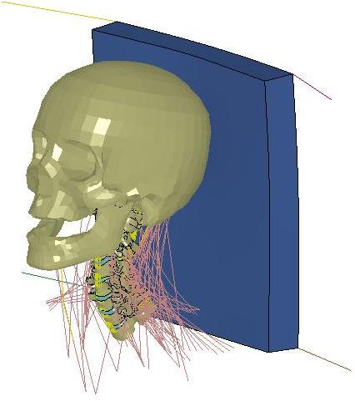

Figure A3: Cervical spine model shown with headrest for 4g rear impact.



Figure A4: T1 prescribed motions for a 7g rear-impact (Adapted from Deng 1999).



Figure A5: T1 Inputs for a 10g rear impact (Adapted from Deng 1999).

**APPENDIX B**

The model geometry was constructed from a commercial data package of a human cervical spine (Viewpoint DataLab; Orem, UT). The linear distance between the C7-T1 joint and the occipital condyles was 121.4 mm, and compared well with the 118.8 mm length of a seated mid-sized male (Robbins, 1983). The initial cervical spine curvature, as defined by Klinich et al (2004), had an inferior Bezier angle of 17.5° and a superior Bezier angle of 14.7°, classifying the model as has having a slight to moderate mid-lordotic curve (LM1/2). This level of curvature represents the most common natural cervical spine curvature for seated adults (Klinich et al., 2004). Dimensions of the IVDs, vertebral bodies, and facet joints were in good agreement with existing anatomical studies (Figures B1-B4; Gilad and Nissan, 1986; Panjabi et al., 1993).



Figure B1: Model intervertebral disc height compared to experimental measurements (mean ± 1 SD).

T

Transverse Plane

Facet Height

Facet Width

S

Sagittal Plane

VB Depth

VB

Height

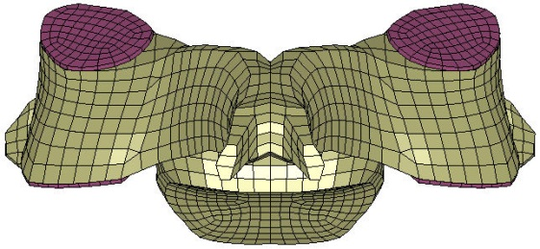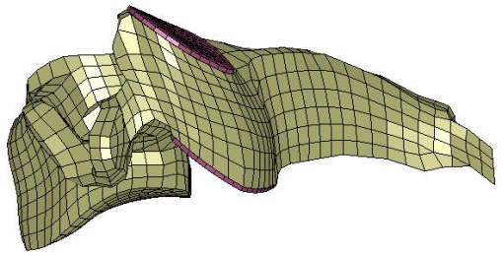

Figure B2: Vertebral dimensions.



|  |  |
| --- | --- |
| A | B |

Figure B3: Model vertebral body height (A) and depth (B) compared to experimental measurements (mean ± 1 SD).



|  |  |
| --- | --- |
| A | B |



|  |  |
| --- | --- |
| C | D |

Figure B4: Model facet height (A), depth (B), transverse angle (C) and sagittal angle (D) compared to experimental measurements (mean ± 1 SD).

Upper and lower cervical spine ligaments were attached to the vertebrae and skull based on anatomical sites using tension-only beam elements. Typically, seven beam elements spaced no more than 1mm apart were used to represent each ligament. The ligaments were modeled using a normalized nonlinear load-deflection curve identified by three distinct regions (Chazal et al., 1985; Figure B5A). The failure force and failure deflection data for each ligament of the cervical spine were based on biomechanical studies (Table B1). To account for viscoelastic effects, a stiffness scale factor based on the dynamic tensile results of the anterior longitudinal ligament (ALL) and ligamentum flavum (LF) (Yoganandan et al., 1989) was applied to the ligaments. The stiffness values of the ligaments at 25, 250, and 2500 mm/s were normalized to the stiffness at 9 mm/s, and a logarithmic curve was fit to this data to define the dynamic stiffness factor (Figure B5B).



|  |  |
| --- | --- |
| A | B |

Figure B5: (A) Normalized ligament force-deflection curve, and (B) dynamic scale factor as a function of ligament deformation rate (experimental mean ± 1 SD).

Table B1: Force Deflection Points for the Ligaments in the Cervical Spine Model

|  |  |  |  |  |  |  |  |
| --- | --- | --- | --- | --- | --- | --- | --- |
| Ligament | Level | Point A | | Point B | | Point C | |
| d (mm) | F (N) | d (mm) | F (N) | d (mm) | F (N) |
| Anterior Longitudinal (ALL) | C2-C5 | 1.22 | 10.04 | 4.48 | 79.89 | 5.8 | 93 |
| C5-T1 | 1.37 | 15.66 | 5.02 | 124.56 | 6.5 | 145 |
| Posterior Longitudinal (PLL) | C2-C5 | 0.88 | 6.96 | 2.71 | 55.31 | 3.5 | 71 |
| C5-T1 | 1.53 | 18.42 | 4.72 | 146.45 | 6.1 | 188 |
| Ligamentum Flavum (LF) | C2-C5 | 1.86 | 25.29 | 4.95 | 108.05 | 6.5 | 121 |
| C5-T1 | 2.69 | 26.96 | 7.16 | 115.20 | 9.4 | 129 |
| Capsular Ligament  (CL) | C0-C1 | 1.50 | 49.28 | 4.35 | 275.20 | 5.7 | 320 |
| C1-C2 | 3.06 | 48.36 | 8.85 | 270.04 | 11.6 | 314 |
| C2-C5 | 2.69 | 18.48 | 7.78 | 103.20 | 10.2 | 120 |
| C5-T1 | 2.06 | 27.87 | 5.95 | 155.66 | 7.8 | 181 |
| Interspinous Ligament (ISL) | C1-C5 | 1.94 | 7.84 | 4.69 | 35.45 | 6.3 | 39 |
| C5-T1 | 2.06 | 7.84 | 4.98 | 35.45 | 6.7 | 39 |
| Tectorial Membrane | C0-C2 | 3.14 | 11.70 | 9.08 | 65.36 | 11.9 | 76 |
| A. Altanto-Occipital | C0-C1 | 4.99 | 35.73 | 14.42 | 199.52 | 18.9 | 232 |
| A. Altanto-Axial | C1-C2 | 2.19 | 40.50 | 6.33 | 226.18 | 8.3 | 263 |
| P. Altanto-Occipital | C0-C1 | 4.78 | 12.78 | 13.81 | 71.38 | 18.1 | 83 |
| P. Altanto-Axial | C1-C2 | 2.53 | 17.09 | 7.32 | 95.46 | 9.6 | 111 |
| Apical | C0-C2 | 2.11 | 32.96 | 6.10 | 184.04 | 8.0 | 214 |
| Alars (Occipital) | C0-C2 | 3.72 | 54.98 | 10.76 | 307.02 | 14.1 | 357 |
| Alars (Atlantal) | C1-C2 | 3.72 | 54.98 | 10.76 | 307.02 | 14.1 | 357 |
| Transverse | C1-C2 | 1.32 | 54.52 | 3.82 | 304.44 | 5.0 | 354 |
| Vertical Crus | C0-C2 | 3.30 | 67.14 | 9.54 | 374.96 | 12.5 | 436 |

The Hill-type muscle model was used to simulate the active and passive muscle behavior in the model. Active muscle force is a function of muscle length, velocity, and active state dynamics (Equation B1). The product of these functions determines the scale-factor that is applied to the maximum isometric force (Fmax) produced in the muscle. Fmax is a product of the muscle physiological cross-sectional area (PCSA) and the maximum muscle stress. Force-length (fFL) and force-velocity (fFV) relationships are nonlinear phenomena based on the current state (length and velocity) of the muscle. The force-length relationship describes isometric muscle force development based on the current length of the muscle and its optimal length (Equation B2). The force-velocity relationship describes the muscle force development as a function of shortening or lengthening, relative to the isometric force (Equation B3). Both the force-length and force-velocity relationships used in the cervical spine model can be seen in Figure B6.

|  |  |  |
| --- | --- | --- |
|  |  | Equation B1 |
|  |  | Equation B2 |
|  | *for V < 0*  *for V > 0* | Equation B3 |



|  |  |
| --- | --- |
| A | B |

Figure B6: Muscle relationships for force-length (A) and force-velocity (B).

Active state dynamics (A) is a time-dependent function based on neural input to the muscle. Neural excitation (and de-excitation) represents the process of converting an idealized neural input into an output signal resembling an EMG output. Active (and de-active) state dynamics represents the transient dynamics between the neural excitation and muscle contraction. Neural excitation and active state dynamics are described using two 1st order systems (Happee, R., 1994; Equation B4; Equation B5).

|  |  |  |
| --- | --- | --- |
|  |  | Equation B4 |
|  |  | Equation B5 |

Where u(t) is the idealized neural input (0 < u(t) < 1), ne is the neural excitation time constant, and a is the active state time constant. When E > A, the muscle is in a state of activation, and a = ac; when E < A, the muscle is in a state of de-activation, and a = dc. The activation time constant (ac) is smaller than the deactivation time constant (dc), which results in muscle activation responding faster than muscle de-activation. The activation state for the flexor muscles in the cervical spine model, with neural excitation u(t) beginning at 74 ms and ending at 174 ms, is shown in Figure B7. For rear impact simulations, the extensor muscles activation was set to be 70% of the flexors (Siegmund et al., 2003a; Brault et al., 2000).



Figure B7: Flexor muscle activation for neural input between 74 and 174 ms for rear impact simulation.

The parallel (passive) element of the Hill muscle model represents the tensile behavior of relaxed muscle and surrounding tissue. There is an assumption that the passive muscle does not carry compressive load. The force generated in the muscle by passive resistance is calculated by Equation B6, and the passive force response used in the cervical spine model is shown in Figure B8A. The total muscle response is the sum of both the active and passive components. Figure B8B shows the total isometric force in the muscle over a range of muscle length and activation levels. All Hill-model parameters used in the cervical spine muscle model can be found in Table B2 and all physical muscle properties used the model can be found in Table B3.

|  |  |  |
| --- | --- | --- |
|  | *for L>Lrest* | Equation B6 |



|  |  |
| --- | --- |
| A | B |

Figure B8: (A) Passive muscle response and (B) the total isometric muscle response for various levels of activation (dashed line indicates active contribution only).

Table B2: Hill-Type Muscle Model Parameters

|  |  |  |  |
| --- | --- | --- | --- |
| Parameter | Range in Literature | Value in Model | Reference |
| max | 0.20 – 1.00 MPa | 0.5 MPa | Van Ee et al., 2000  Winters, 1995 |
| PCSA |  | Table B2 | Knaub and Myers, 1998 |
| Sk |  | 6.25 | Winters, 1995 |
| Lopt |  | 1.05 | Winters, 1995 |
| vmax | 2 (Lrest) – 8 (Lrest) /s | 5 (Lrest) /s | Winters and Woo, 1990 |
| CEsh | 0.1 – 1 | 0.55 | Winters and Woo, 1990 |
| CEshl |  | 0.1065 |  |
| CEml | 1.1 – 2.0 | 1.3 | Winters and Woo, 1990 |
| ne | 20 – 50 ms | 35 ms | Winters and Stark, 1985 |
| ac | 5 – 20 ms | 15 ms | Winters and Stark, 1985 Winters, 1995 |
| dc | 20 – 60 ms | 40 ms | Winters and Stark, 1985 Winters, 1995 |
| Lmax | 0.6 – 0.7 | 0.6 | Winters, 1995 |
| Ksh | 3 – 6 | 3 | Winters, 1995 |

Table B3: Cervical Spine Muscle Geometry

|  |  |  |
| --- | --- | --- |
| Muscle Segment | PCSA (cm2) | Total Volume (g/cm3) |
| Oblique Capitus Inferior | 1.95 | 8.13 |
| Oblique Capitus Superior | 0.88 | 3.03 |
| Rectus Capitus Major | 1.68 | 5.37 |
| Rectus Capitus Minor | 0.92 | 1.82 |
| Longus Capitis | 1.37 | 11.09 |
| Longus Colli | 2.75 | 13.79 |
| Rectus Capitis Ant | 1.30 | 1.36 |
| Rectus Capitis Lat | 1.30 | 1.74 |
| Anterior Scalene | 1.88 | 9.56 |
| Middle Scalene | 1.36 | 10.38 |
| Posterior Scalene | 1.05 | 6.38 |
| Sternocleido Mastoid | 4.92 | 56.09 |
| Iliocostalis Cervicis | 1.04 | 7.21 |
| Longissimus Capitis | 0.98 | 12.33 |
| Longissimus Cervicis | 1.49 | 9.71 |
| Multifidus | 2.35 | 24.64 |
| Semisplenius Capitus | 5.52 | 44.67 |
| Semisplenius Cervicis | 3.06 | 24.19 |
| Splenius Capitis | 3.09 | 30.67 |
| Splenius Cervicis | 1.43 | 14.38 |
| Levator Scapula | 3.12 | 37.83 |
| Minor Rhomboid | 1.02 | 7.47 |
| Trapezius | 13.73 | 132.09 |
| Omohyoid | 1.18 | 6.35 |
| Sternohyoid | 1.18 | 5.81 |

**APPENDIX C**



Figure C1: Model response in tension.



|  |  |
| --- | --- |
| A | B |



|  |  |
| --- | --- |
| C | D |



|  |  |
| --- | --- |
| E | F |



|  |  |
| --- | --- |
| G | H |

Figure C2: Local tissue response during dynamic frontal impact vs. experimental response (mean ± 1 SD). Peak ligament tensile strain for (A) PLL, (B) LF, (C) anterior CL, (D) posterior CL, (E) anterior ISL, and (F) posterior ISL, and peak shear strain for (G) anterior IVD, and (H) posterior IVD.



|  |  |
| --- | --- |
| A | B |



|  |  |
| --- | --- |
| C | D |



|  |  |
| --- | --- |
| E | F |

Figure C3: Global kinematic response during dynamic frontal impact vs. experimental corridors (mean ± 1 SD). Head C.G. acceleration in X, Z and Y rotation for 8G (A, C, E), and 15G (B, D, F) impact cases (Thunnissen et al., 1995).